Phase 2 Meal Template
Calorie Goal – 40% from fat, 35% from carbohydrates, 25% from protein

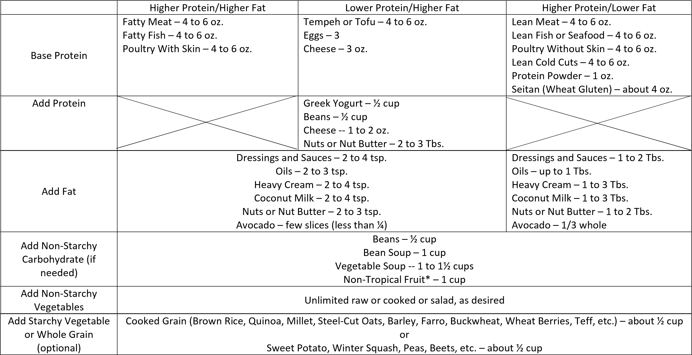
*Tropical or dried fruit sparingly

No flour, sugar, potatoes or other simple carbohydrates are allowed except for a very small amount of honey or maple syrup as per the book. Revised 2/12/16

